支付宝支付
第一步：测试用支付宝的沙箱环境：支付宝开放平台 ( https://auth.alipay.com/login/ant_sso_index.htm?goto=https%3A%2F%2Fopenhome.alipay.com%2Fdevelop%2Fsandbox%2Fapp )
第二步：生成公钥私钥：生成密钥 - 支付宝文档中心 ( https://opendocs.alipay.com/common/02kipl )
第三步：配置公钥私钥
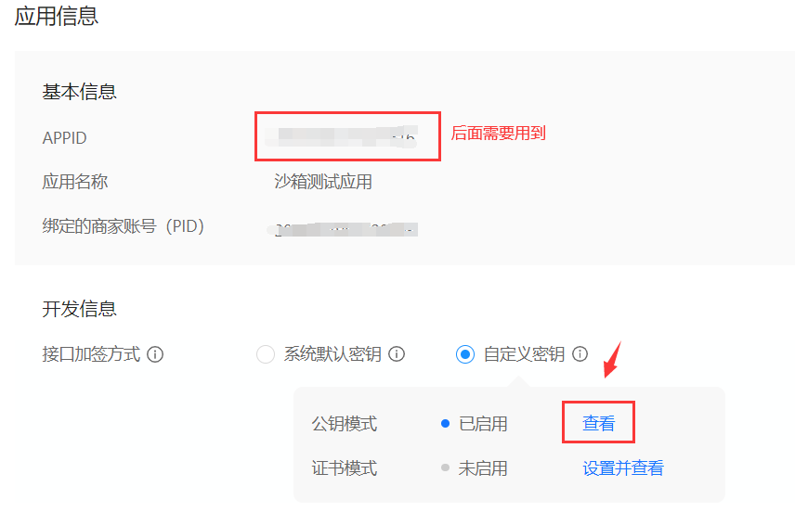
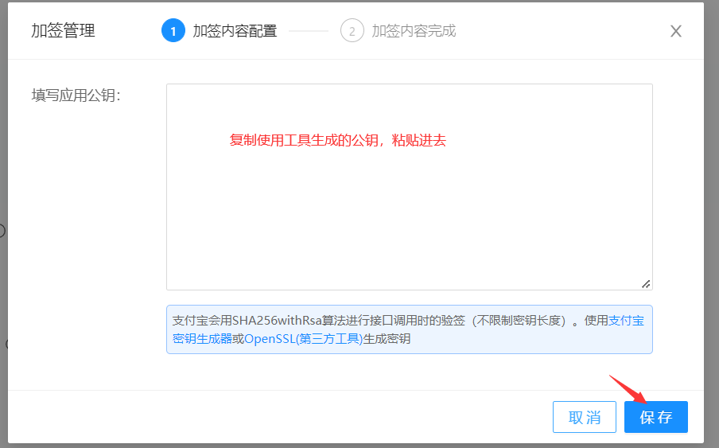
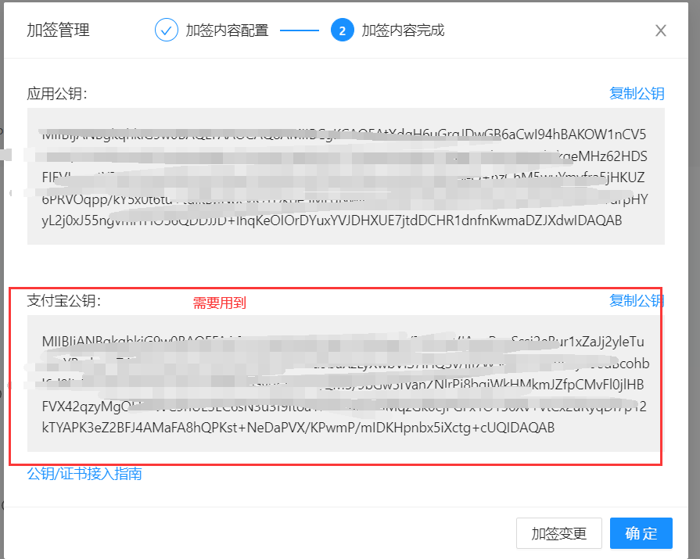
第三步：安装模块
pip install python-alipay-sdk
第四步：基本使用
from alipay import AliPayfrom alipay.utils import AliPayConfig

app_private_key_string = open("./应用私钥2048.txt").read()
alipay_public_key_string = open("./支付宝公钥.txt").read()

# 应用私钥格式"""
-----BEGIN RSA PRIVATE KEY-----
base64 encoded content
-----END RSA PRIVATE KEY-----
"""# 支付宝公钥格式"""
-----BEGIN PUBLIC KEY-----
base64 encoded content
-----END PUBLIC KEY-----
"""

alipay = AliPay(
appid="2021000121627616",
app_notify_url=None, # 默认回调 url
app_private_key_string=app_private_key_string,
# 支付宝的公钥，验证支付宝回传消息使用，不是你自己的公钥,
alipay_public_key_string=alipay_public_key_string,
sign_type="RSA2", # RSA 或者 RSA2
debug=False, # 默认 False
verbose=False, # 输出调试数据
config=AliPayConfig(timeout=15) # 可选，请求超时时间
)

res = alipay.api_alipay_trade_page_pay(
out_trade_no='1000101', # 订单号
total_amount=float(999), # 价格
subject='气球', # 名称
return_url='http://127.0.0.1:8080/pay/success/', # 支付成功后会跳转的页面
notify_url='http://127.0.0.1:8000/order/', # 回调地址，支付成功后支付宝会向这个地址发送post请求
)

gataway = 'https://openapi.alipaydev.com/gateway.do?'# 支付链接
pay_url = gataway + resprint(pay_url)
访问支付链接，用沙箱账户登录支付
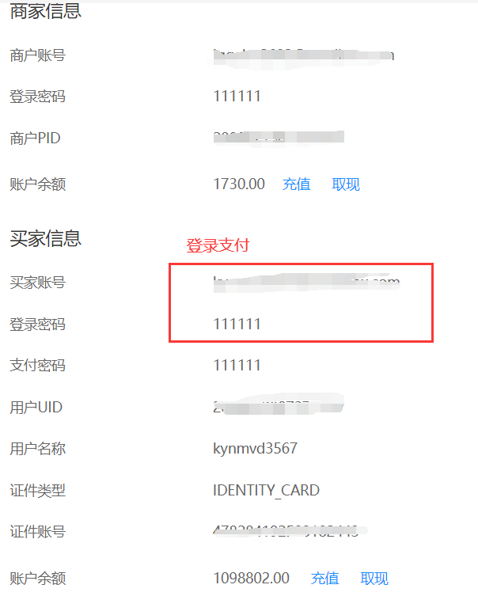
支付成功后，会跳转到代码中写的地址(http://47.93.12.75:8888/appcode/getTime.dspy)，完整链接：
https://openapi.alipaydev.com/gateway.do?app_id=2021000118630124+&biz_content=%7B%22subject%22%3A%22iphone+13+pro%22%2C%22out_trade_no%22%3A%228454665226666%22%2C%22total_amount%22%3A1%2C%22product_code%22%3A%22FAST_INSTANT_TRADE_PAY%22%7D&charset=utf-8&method=alipay.trade.page.pay&notify_url=http%3A%2F%2F47.93.12.75%3A8888%2Fappcode%2FgetTime.dspy&return_url=http%3A%2F%2F47.93.12.75%3A8888%2Fappcode%2FgetTime.dspy&sign_type=RSA2&timestamp=2023-05-06+14%3A22%3A37&version=1.0&sign=MIOgGMgO908fDr62BkFXU%2BUndhviuHRAGVP%2BtUxGTRKeOQZbCx%2FMcv%2BvOuj46PvjlixxcJ%2B7WfDvZMg1siuOmLczBBrzEgU0FXEB9MJhyb4otxAX8Q9XsC2eVoHZhapywrjBGhh5TeAoBqHbbO%2B1g%2Bgawc%2BKfS4RpGVYTCGHCkQLCkHTXVZfenpGEOsmrCDoMQCwVujApvJPeEYwjDD0FKEHIT2OG3LtFYdfVPIPHi2k%2B0fwmoYPMqOCTorgazgaNrWCmudozL79dpkT%2FYCfTIUt86RYjceiKjsap4vCwmc8TBF7dqwAxNnQSAQ1lUObo23pc4gTy43z1KwVp5hN5A%3D%3D
比较有用的参数：
out_trade_no=64d01b38-fa0d-4cb9-98d6-e425475022c1 # 订单号
total_amount=299.00 #订单价格
trade_no=2022072022001479300501762515 # 支付宝流水号
timestamp=2022-07-20%2009%3A33%3A47 # 支付时间

回调地址
支付宝支付成功后，会向我们写的地址，也就是上面写的参数
notify_url='http://47.93.12.75:8888/appcode/getTime.dspy’

